**BY, TEAM DEFENDERS**

Surbhit Vishwakarma

Amey Agnihotri

Roshani Pagare

Pratik Mahajan

Aishwarya Gaikwad

**MENTORED BY:**

Arya Raj

PROJECT REPORT ON

**AUDIT LOG**

2022

**PROJECT REPORT ON AUDIT LOG**

* **PROJECT TITLE:**

Audit Log Web Application

* **INTRODUCTION:**

AUDIT-LOG is Restful API based application which is developed using Spring Boot Framework. This application is used to view logs based on mobile plan project in the form of operation type, entity JSON & timestamp.

Technologies and Tools used:

* Frontend:*HTML, CSS, JavaScript.*
* Backend**:** *Spring, MariaDB.*
* ToolsUsed**:** *STS, VS Code, Git, Postman, Docker, SQLyog.*
* **DETAILS:**

Audit Logs can perform various operations. They are as follows:

|  |  |  |
| --- | --- | --- |
| 1 | VIEW LOG | This function allows user to add new mobile plans. |
| 2 | SEARCH LOG | This function allows user to get all the mobile plans. |

* **WORKFLOW:**

Mobile-Plan Application workflow is as follows:

* Audit Log Spring Boot App (Running on Tomcat Server Port 8081) - (client Request).
* The controller will accept the request.
* Controller goes to the Service Class.
* Function Call i.e., View Logs.
* Fetches the Data from Maria Database.
* It will send the response to client.
* **PLANNING:**

This Project is divided into 4 epics:

1. Rest API Creation in Spring Boot Application
2. UI and It’s integration with Spring boot Application
3. UI Improvement
4. Documentation & Testcases

* **IMPLEMENTATION:**

1. For Backend Part:

* In Audit Log, the controller class is responsible for processing incoming REST API requests such as Get logs i.e. View logs and search logs.

1. For Frontend Part:

* The frontend also called Client-Side programming which is mediator between user and the controller class.
* In Audit Logs we have pages like View logs and search logs by ID.

* **SCREENSHOTS:**

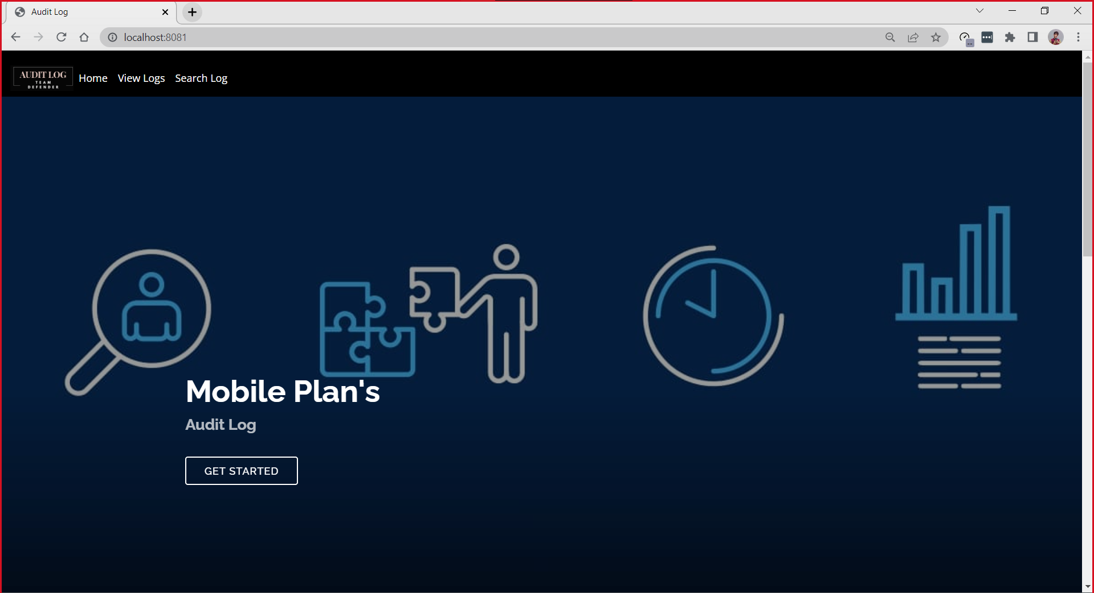

Home Page

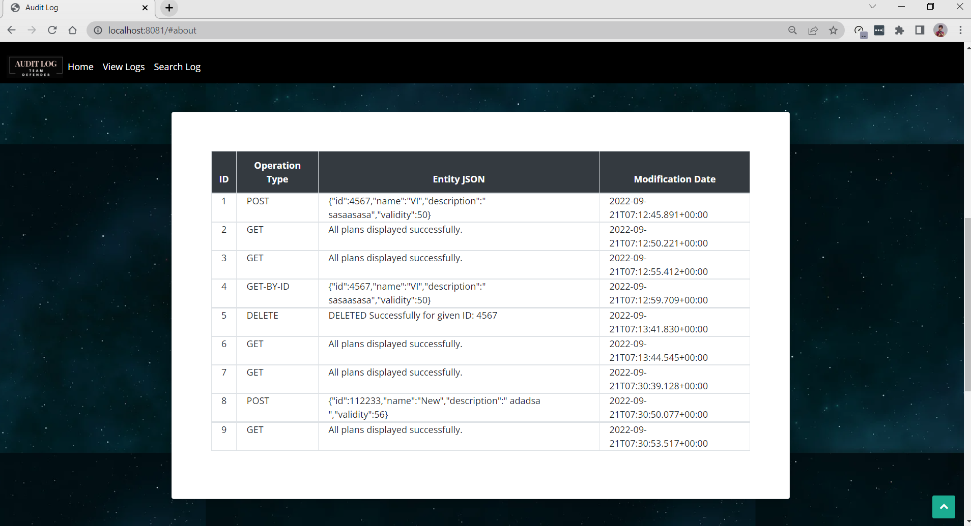

View Logs

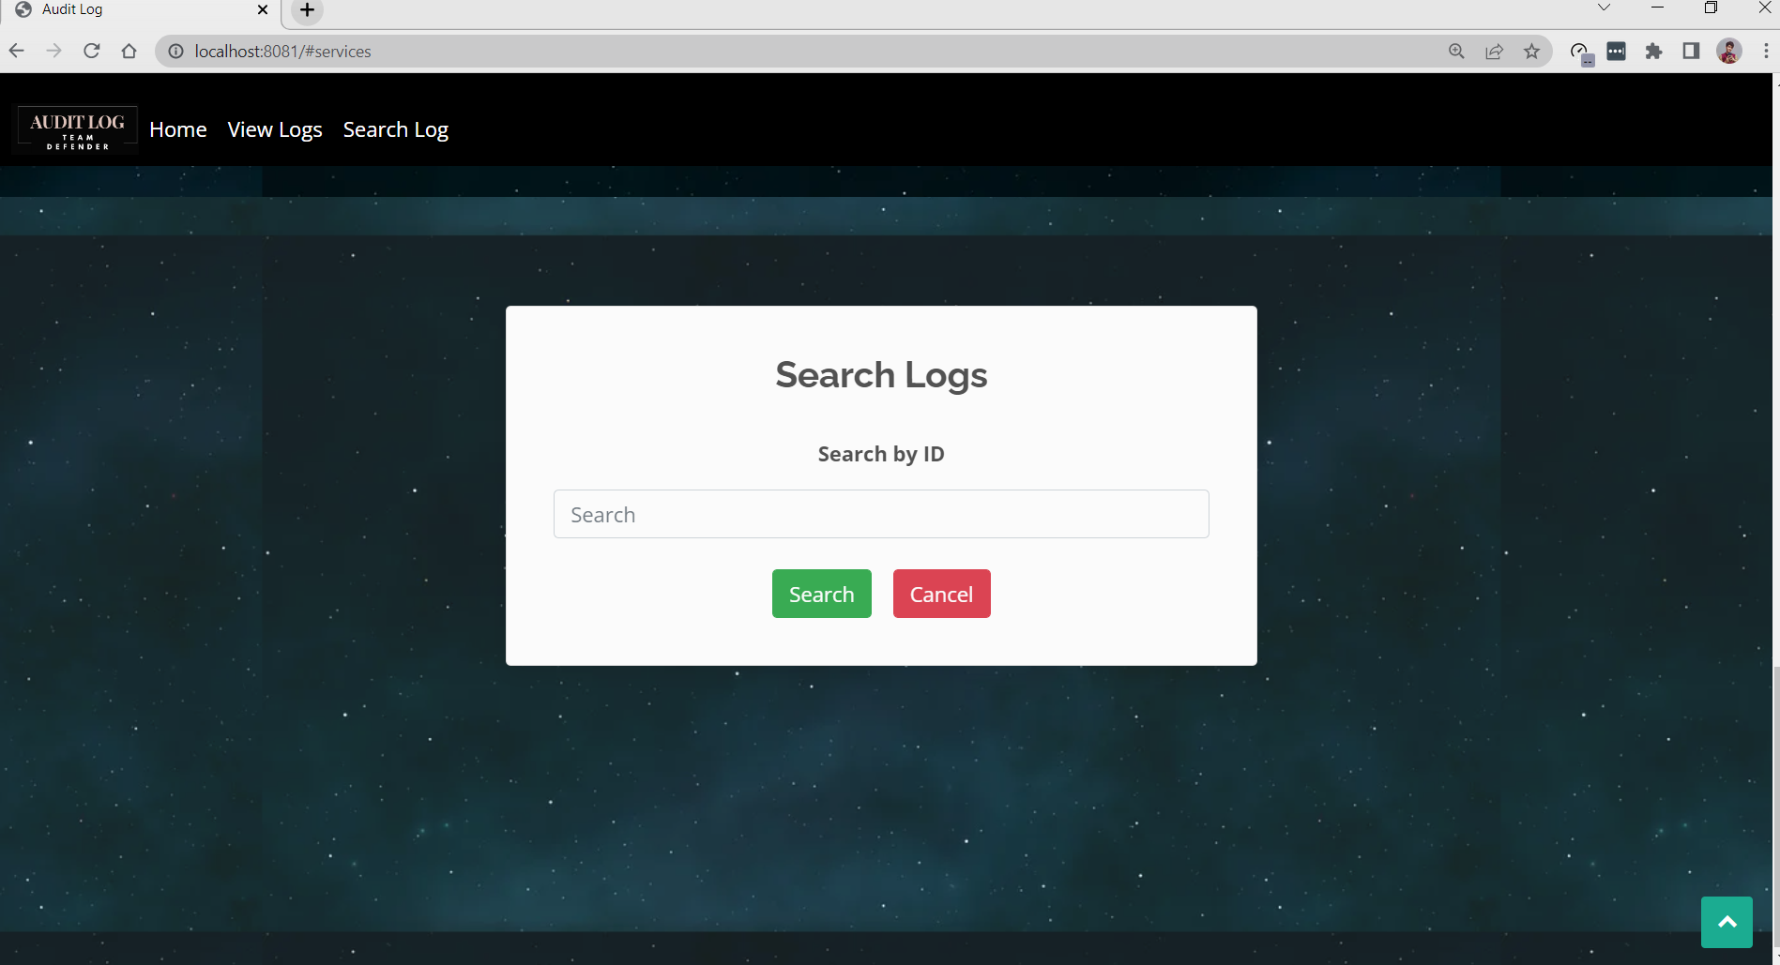

Search Logs